

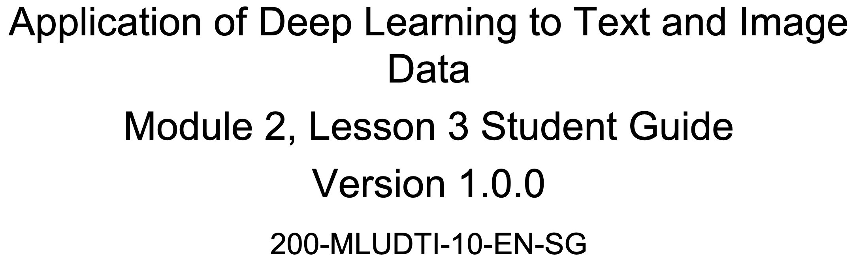



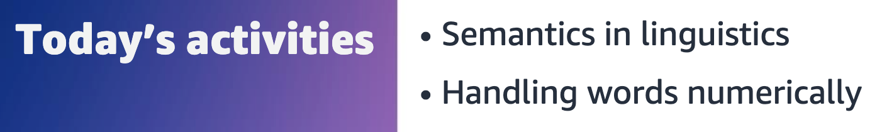



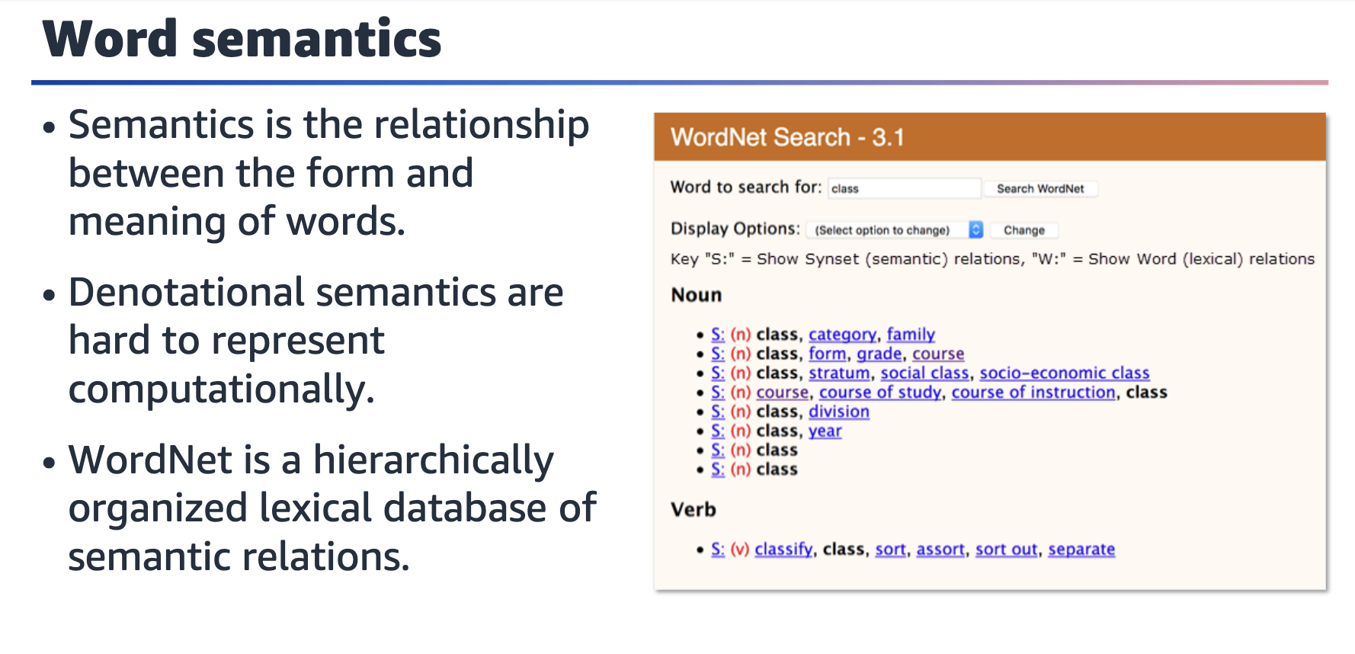

In linguistics, semantics is the subfield that studies meaning. Semantics can address

meaning at the levels of words, phrases, sentences, or larger units of discourse. One

topic that unites different approaches to linguistic semantics is that of the

relationship between form and meaning.

WordNet is a lexical database of semantic relations between words in more than 200 languages. WordNet links words into semantic relationships including synonyms, hyponyms, and meronyms.

For the definition of hyponym, see the Cambridge Dictionary at

<https://dictionary.cambridge.org/us/dictionary/english/hyponym>. For the definition

of meronym, see Dictionary.com at <https://www.dictionary.com/browse/meronym>.

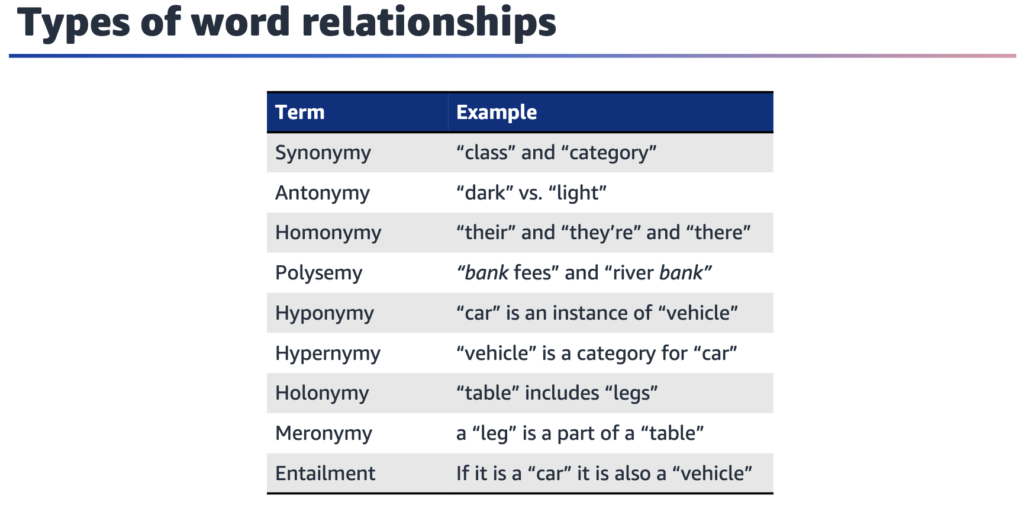

The slide lists linguistic concepts and relationships that commonly studied in

semantics. Each term represents a different way that words can be related to each

other:

• Synonym: Word that has the same or a similar meaning.

• Antonym: Word with the opposite meaning.

• Homonym: Word that is spelled or pronounced the same way but has a different meaning.

• Polysemous word: Word that has multiple meanings.

• Hyponym: Word that denotes a specific instance of a more general class.

• Hypernym: Word that describes a set of items more broadly.

• Holonym: Word that denotes a whole.

• Meronym: Word that denotes a part.

•Entailment: Describes the relationship between words where the truth of one

word implies the truth of another.

Reference: Daniel Jurafsky and James H. Martin. “Word Senses and WordNet.” Chap. 23 in Speech and Language Processing. 2023. <https://web.stanford.edu/~jurafsky/slp3/23.pdf>.

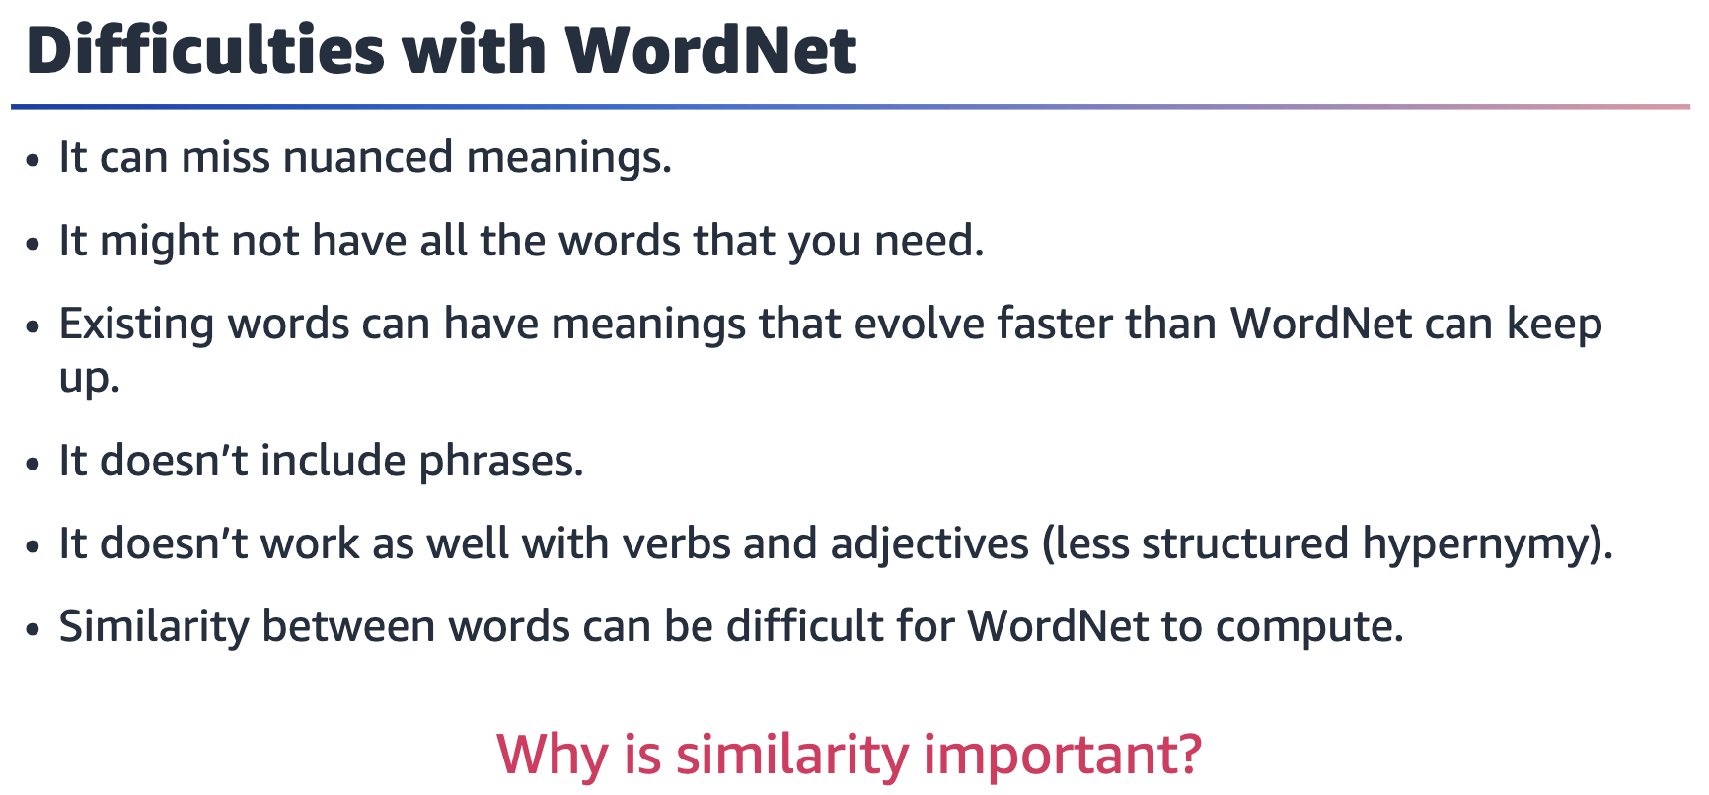

**Missing nuance**: WordNet is a relatively coarse-grained resource that might not capture subtle distinctions in meaning between words. For example, WordNet might equate proficient with good, but these words aren’t interchangeable in all contexts.

**Missing words**: WordNet might not include all words in a language and might not keep pace with neologisms and changes in usage.

**Evolving meanings**: WordNet might not capture the full range of meanings and connotations of existing words as they evolve over time. For example, covid might have acquired new meanings and associations since its emergence in late 2019.

**No phrases**: WordNet is focused on individual words and doesn’t include phrases or

multiword expressions.

**Limited structure for verbs and adjectives**: The hypernymy relationships between verbs and adjectives in WordNet can be less structured and less well-defined than those for nouns.

**Difficulty computing similarity**: Although WordNet provides a measure of similarity between words, it might not always accurately reflect the semantic relatedness between words in context.

Why is similarity important? Quantifying similarity between the words can help build

a better understanding of text data.

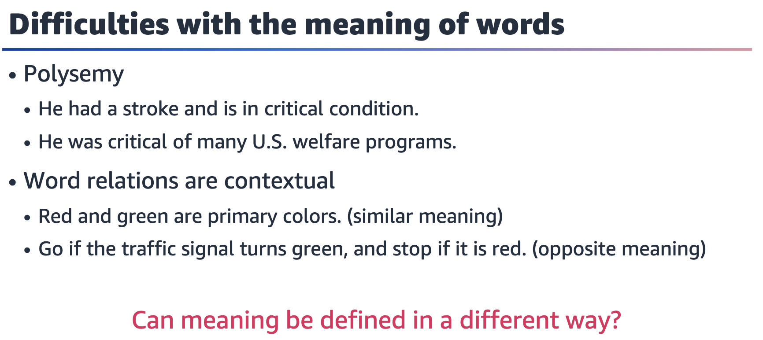

**Polysemy**: Multiple possible meanings for a word or phrase.

Can meaning be defined in a different way? For example, by using numerical

representations?



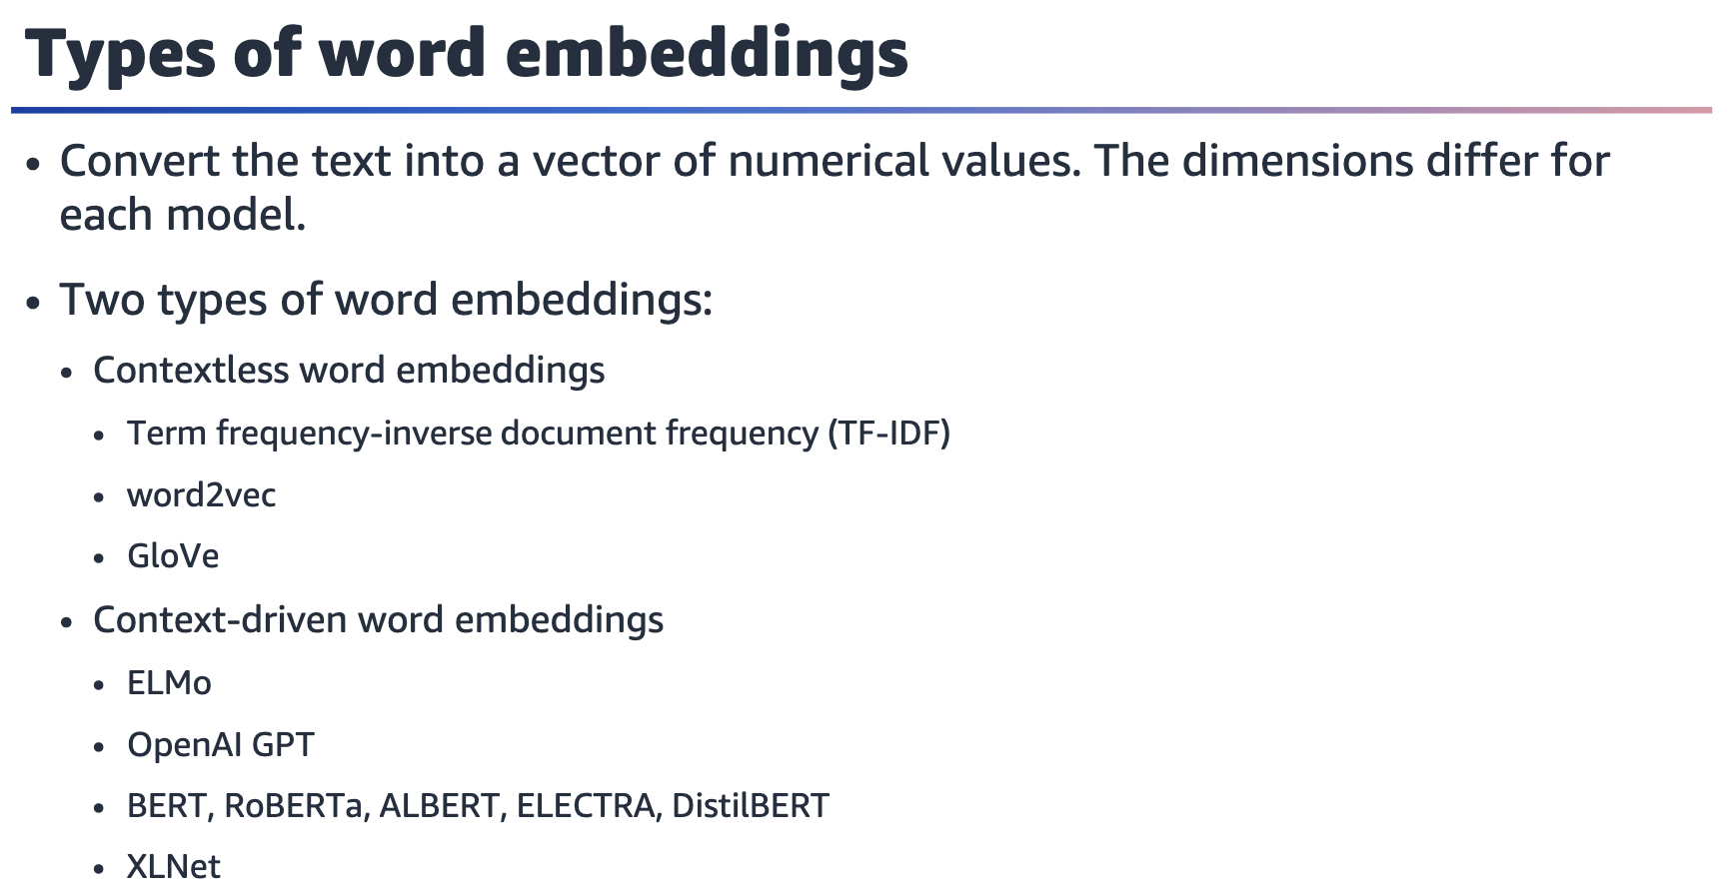

**Contextless word embeddings**

• This type of embedding focuses more on the statistical part of the sentence

structure rather than the context.

• Term frequency-inverse document frequency (TF-IDF) gives priority based on how

often (the frequency) a word is included in a piece of content.

• word2vec is a neural network-based technique to generate word embeddings that

capture the semantic relationships between words.

• GloVe is another neural network-based technique to generate word embeddings

that capture semantic relationships.

• word2vec and GloVe are widely used for a range of natural language processing

(NLP) tasks, including text classification, sentiment analysis, and language translation.

**Context-driven word embeddings**

• These word embeddings consider the context in which the word appears.

• Popular examples include ELMo, OpenAI GPT, BERT, RoBERTa, ALBERT, ELECTRA, DistilBERT, and XLNet.

• They have been shown to improve the performance of many NLP tasks.

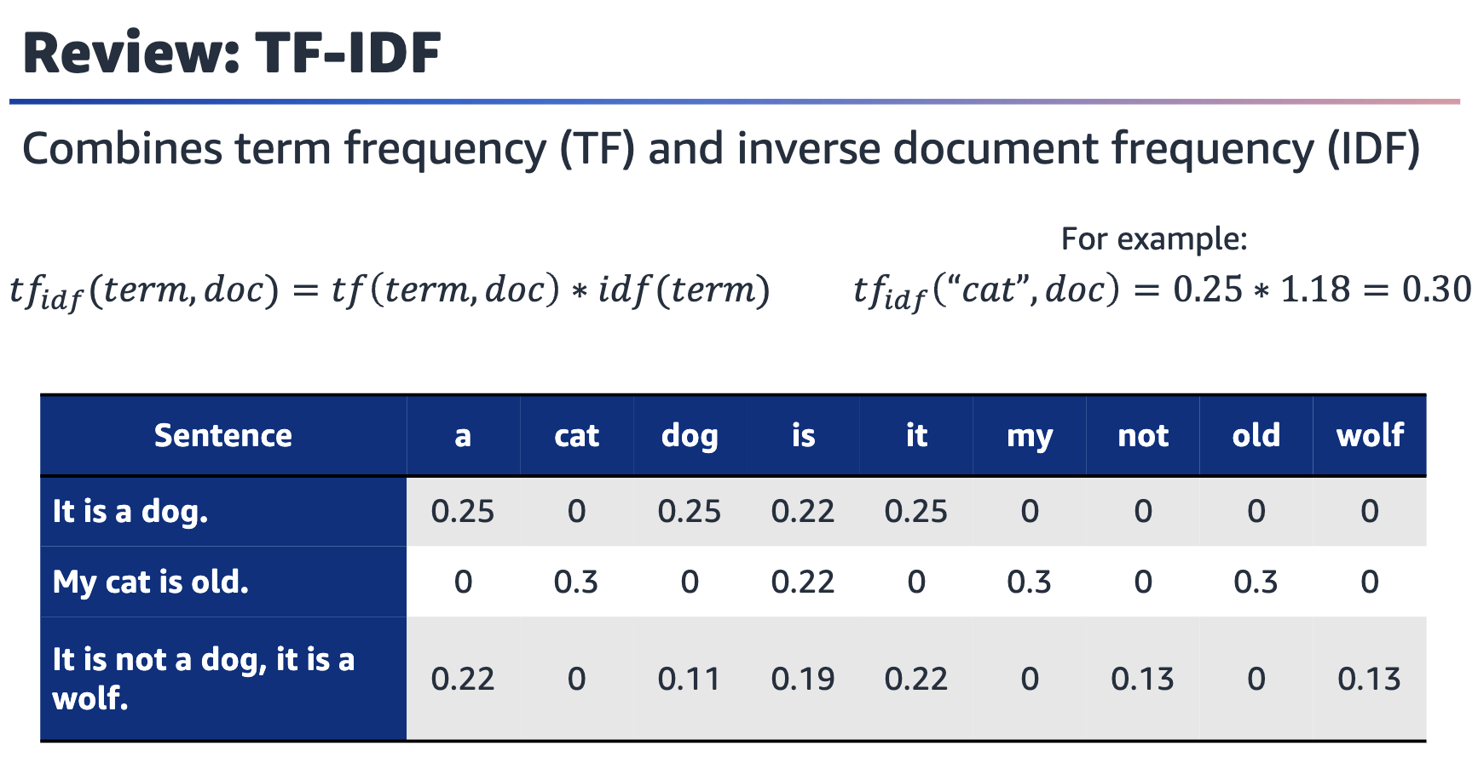

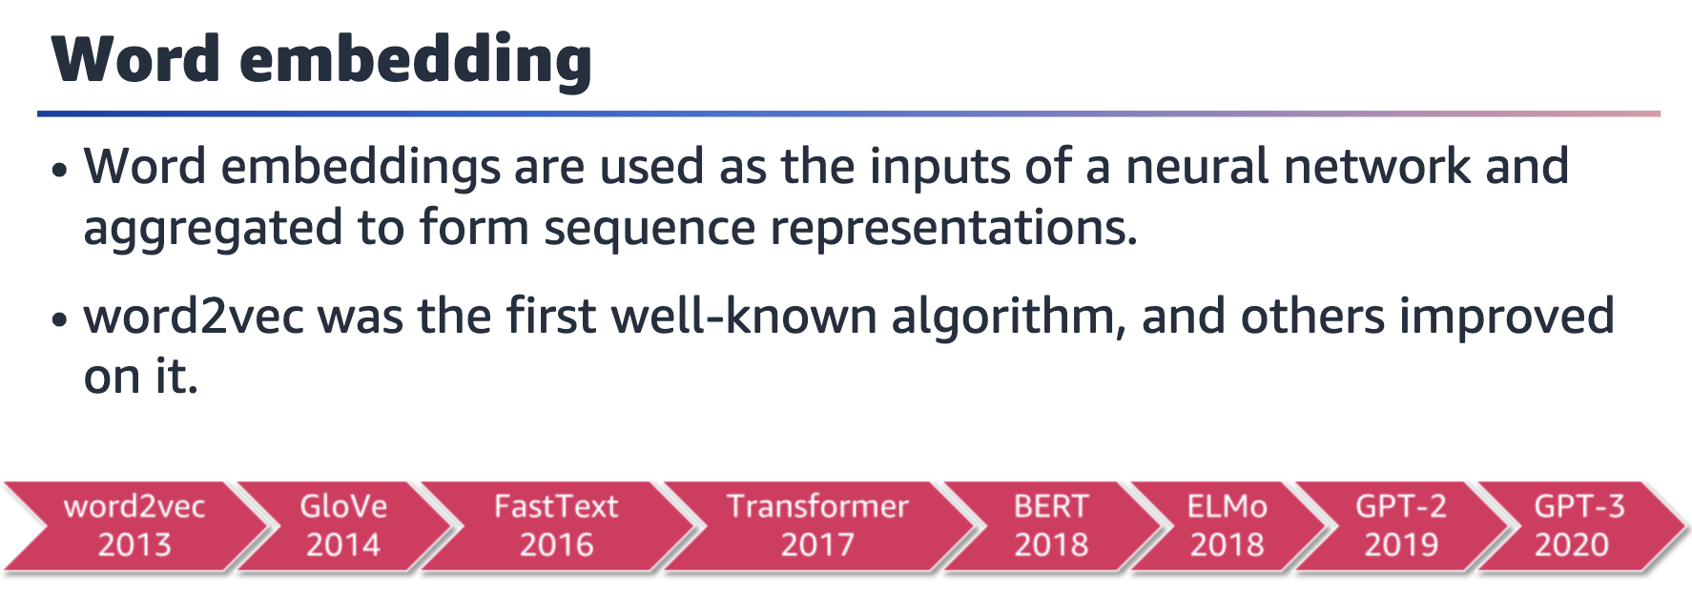

word2vec is a popular algorithm to create word embeddings. It was introduced in

2013 by Tomas Mikolov et al. The algorithm uses a neural network to create word

embeddings by predicting a word's context from its position in a text corpus.

GloVe, which is short for global vectors for word representation, was introduced by

Jeffrey Pennington et al. It’s a method to create word embeddings that considers the

co-occurrence probabilities of words in a corpus.

FastText, which Facebook introduced, is an extension of the word2vec algorithm. It

considers subword information, which provides the ability to handle out-of-vocabulary (OOV) words and rare words more effectively.

The Transformer architecture was introduced by Vaswani et al. and is a type of neural

network that is effective for modeling sequences.

Bidirectional Encoder Representations from Transformers (BERT) is a pretraining

technique to create contextualized word embeddings. It considers the surrounding

context of a word.

ELMo, which is short for Embeddings from Language Models, is another pretraining

technique that creates word embeddings by training a neural network to predict the

next word in a sequence.

OpenAI introduced Generative Pre-trained Transformer 2 (GPT-2), which is a language

model that uses the transformer architecture and is capable of generating coherent

and natural language text. OpenAI introduced GPT-3 as a larger and more powerful

version of GPT, and has been lauded for its ability to generate highly coherent and

contextually relevant text.

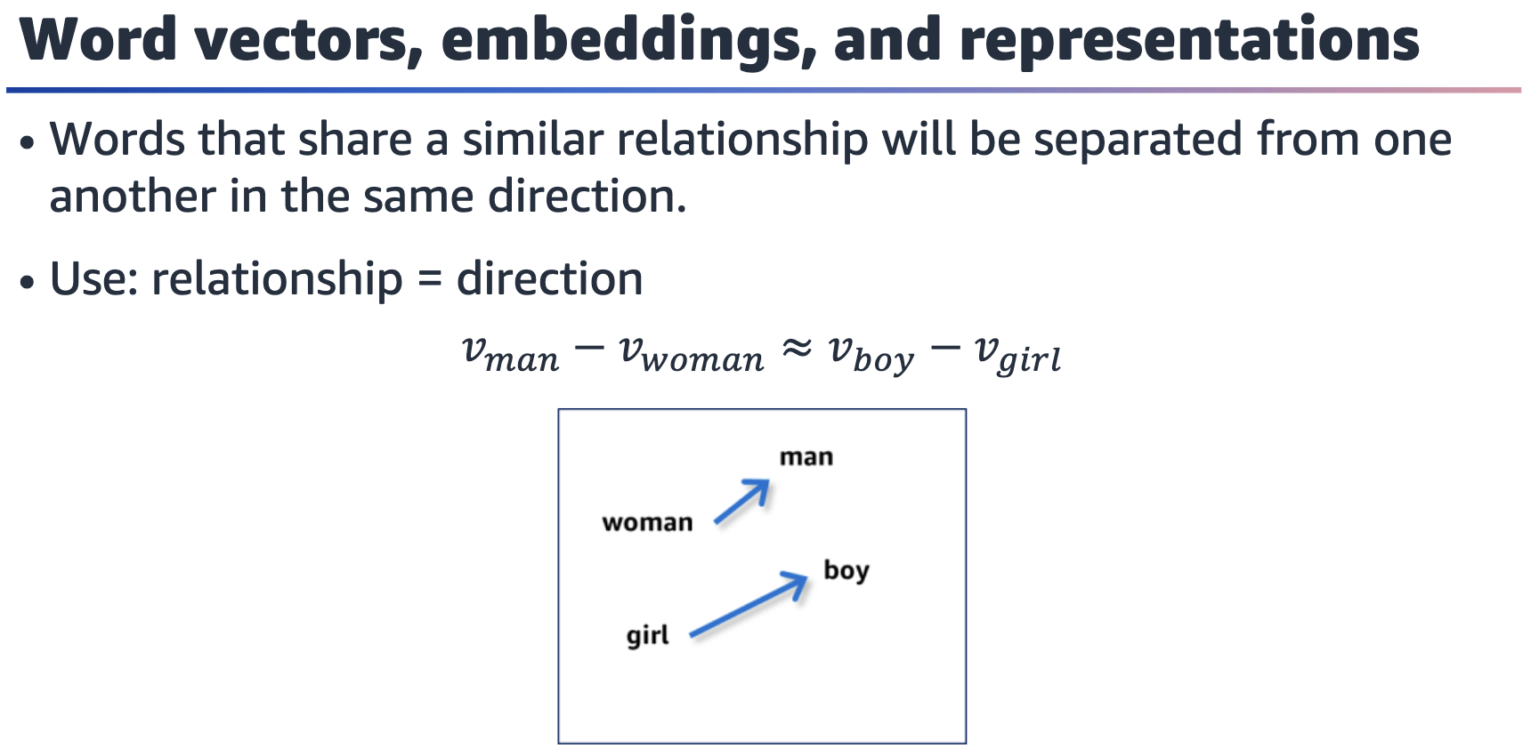

Rendering of the linear algebraic relationship between masculine-feminine pairs. The vector between woman and man is similar to the vector between girl and boy.

Words that are semantically similar will have some similar word vectors. When you

examine word vectors for certain words, you can see this relationship. For example,

when you take the difference for the word vectors between man and woman or boy

and girl, the resulting vectors are similar to each other.

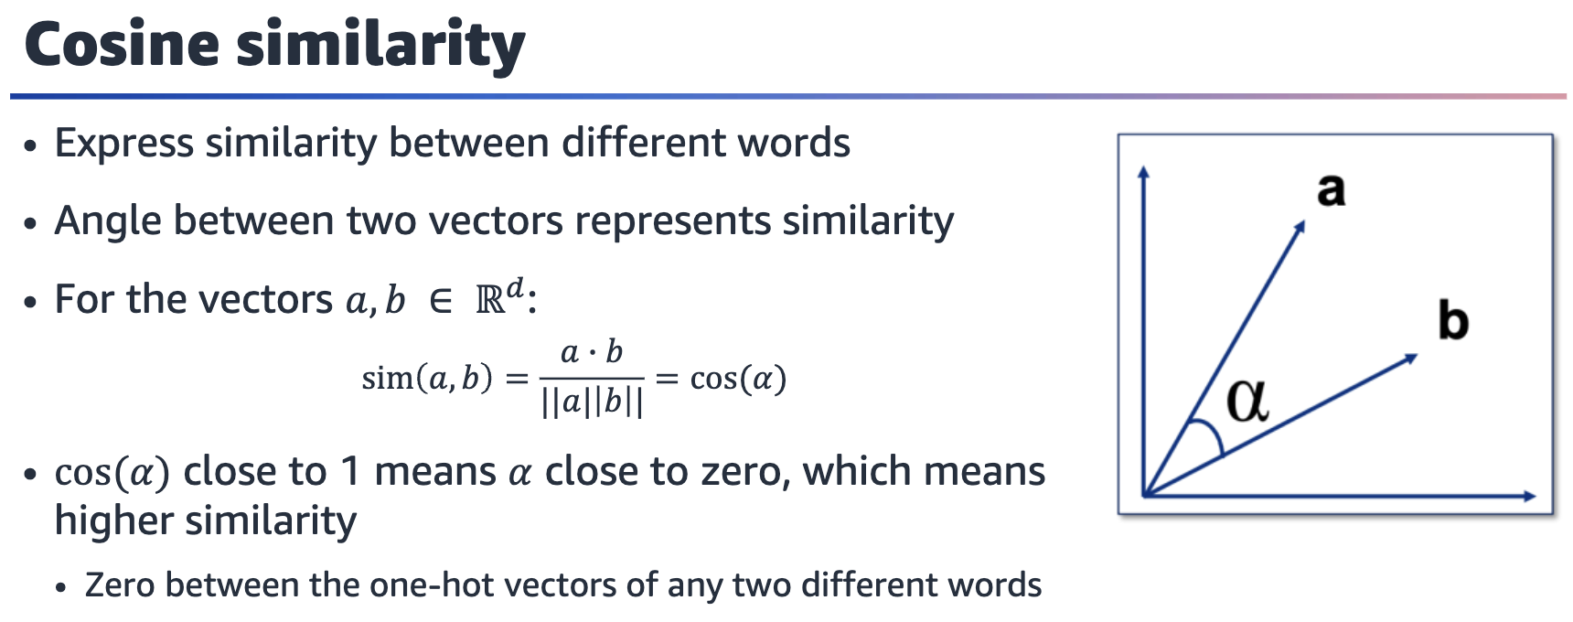

Cosine similarity is a way to measure similarity between two vectors. It is calculated

by using the dot product (numerator) and magnitudes (denominator) of the vectors.

The result is between -1 and 1. The value -1 means that they are the exact opposite

of each other, +1 means that they are exactly the same, and 0 means that they are

orthogonal to each other.

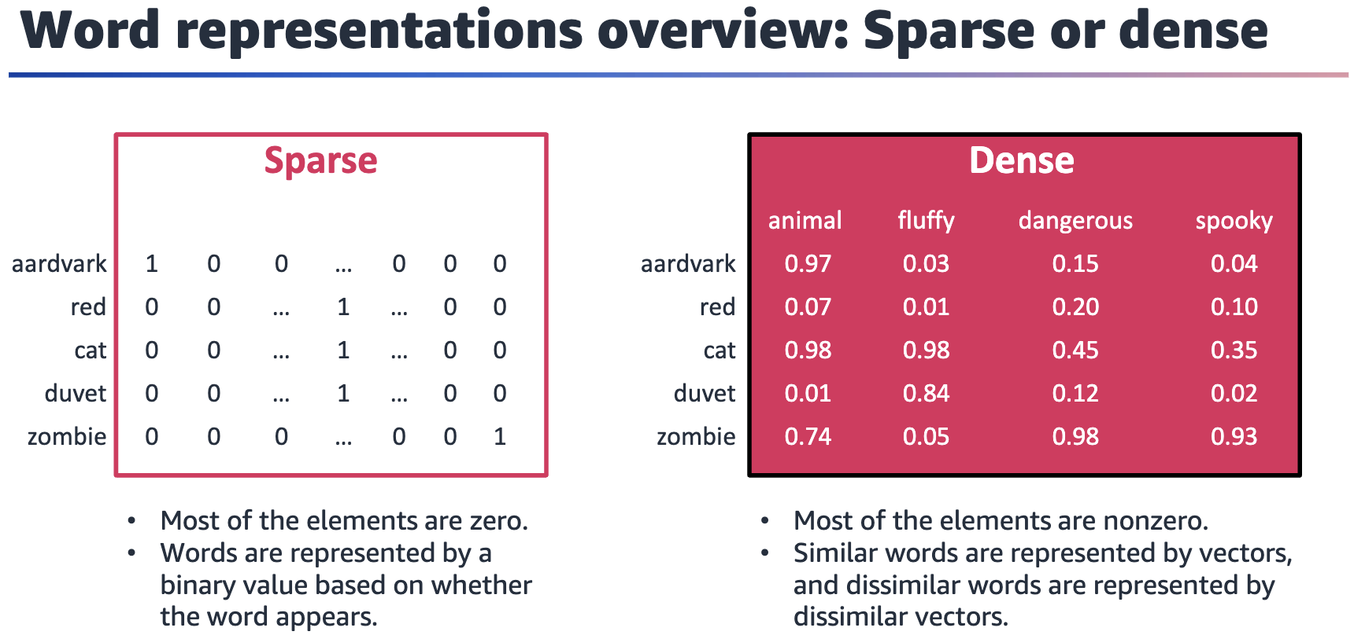

It’s important to distinguish between sparse and dense representations.

In ***sparse representations***, most of the elements are zero. A sparse word representation is a way to represent text data, such as documents or sentences, in which each word is represented by a binary or count value that indicates whether the word is present in the text. This representation is called sparse because the majority of the values in the representation are zero — most words don’t appear in a given text.

***Dense representations*** are the opposite. Most of the elements are nonzero. Dense

representations have several advantages over traditional sparse representations

because dense vectors can capture more subtle relationships between words and are

more efficient to compute with. The goal of dense word representation is to capture

the semantic and syntactic information of words in a continuous vector space, where

similar words are represented by similar vectors and dissimilar words are represented

by dissimilar vectors.

The graphic on the right side of the slide shows a dense representation of the words

*aardvark, red, cat, duvet* and *zombie*. Each word can be represented as a vector of

length 4, with each value representing the weight for a feature: *animal, fluffy*, *dangerous*, and *spooky*. These weight values are normalized to a range [0,1]. You might notice that the word *cat* has a high weight on *animal* and *fluffy* features but low weight on *dangerous* and *spooky* features. The word *zombie* is the opposite.

Dense representation can help to capture semantic relationships and enable transfer

learning.

A common question here is what are these values? The answer is they are learned

through training with a text corpus.

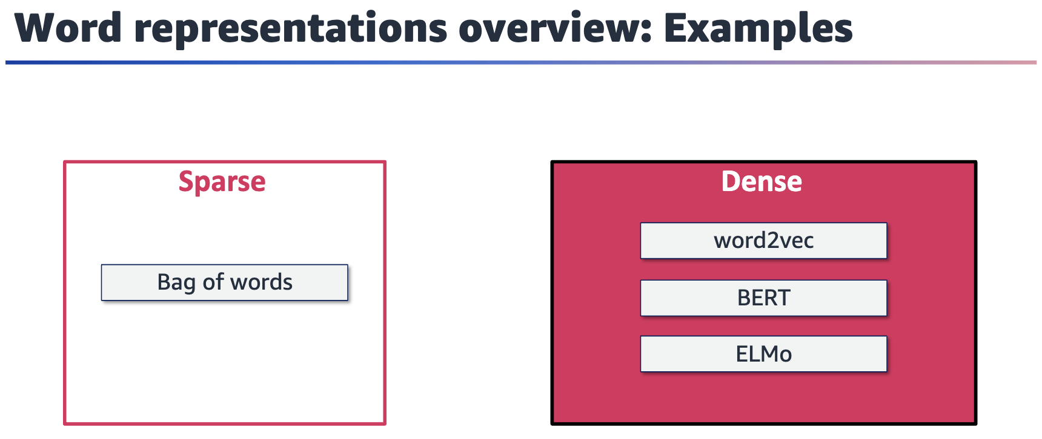

A bag of words is a type of sparse word representation that simply counts the

occurrence of each word in the text and ignores the order that the words appear in.

Word vectors provide dense representations. word2Vec is a popular technique to

generate dense representations of words, also known as word embeddings. This

lesson will shows how these values are learned by using word2vec. Some other

examples of dense embeddings are BERT embeddings, ELMo, and GPT.

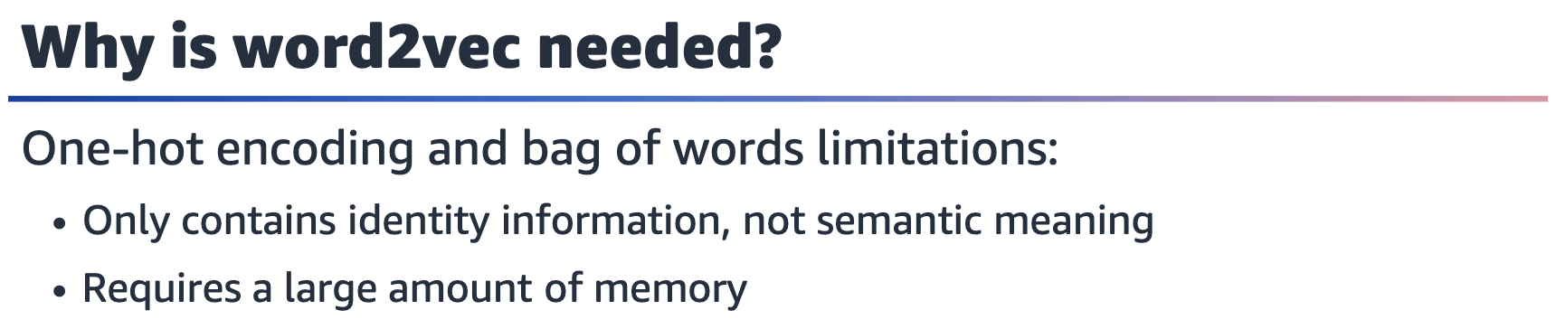

One-hot encoding example of identity but not semantic meaning: The first word in

the vocabulary is [1, 0, 0, 0..], the second is [0, 1, 0, ..], and so forth.

Similarly, the bag-of-words method doesn’t capture any semantic information about

the words in the text. The method has limited representational power for tasks that

require understanding the meaning of phrases or sentences.

In addition to these representational limitations, one-hot encoding and bag of words

can require a large amount of memory to store the vectors or matrices that are used

to represent text, especially for large vocabularies or large datasets.

To address these limitations, researchers have developed more advanced techniques

to generate dense word embeddings, such as word2Vec, GloVe, and FastText. These

techniques can capture semantic meaning and are more memory efficient than one-hot encoding or bag of words.

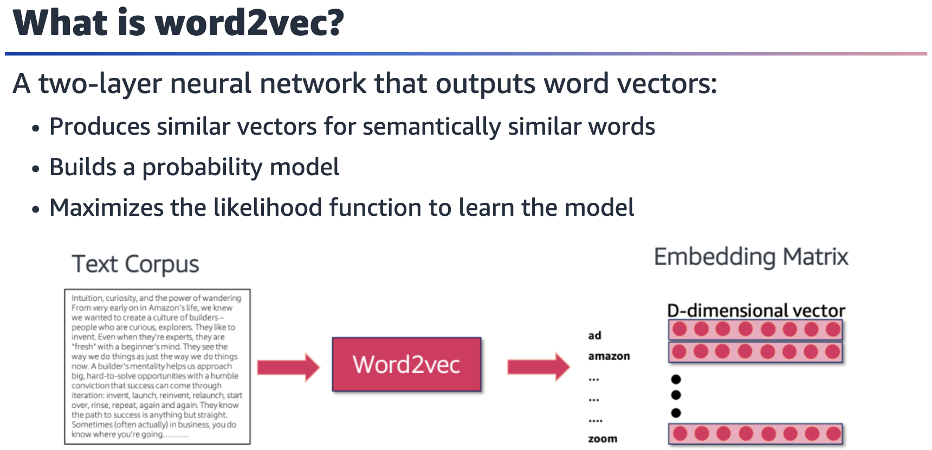

Diagram showing that the input to the word2vec model is the text corpus, and the output is a D-dimensional embedding matrix. In the matrix, each row represents the word in the vocabulary generated from a text corpus.

As the name suggests, word2vec gets vectors for the words that are used. One-hot encoding doesn’t contain any semantic information. You have a single 1 at a location

that is usually decided based on the place in the vocabulary. For example, the first

word in the vocabulary is [1, 0, 0, 0..], the second is [0, 1, 0, ..], and so forth.

word2vec learns the word vectors using a simple two-layer technique. This technique

produces similar word vectors for semantically similar words. It does this by building

a probability model.

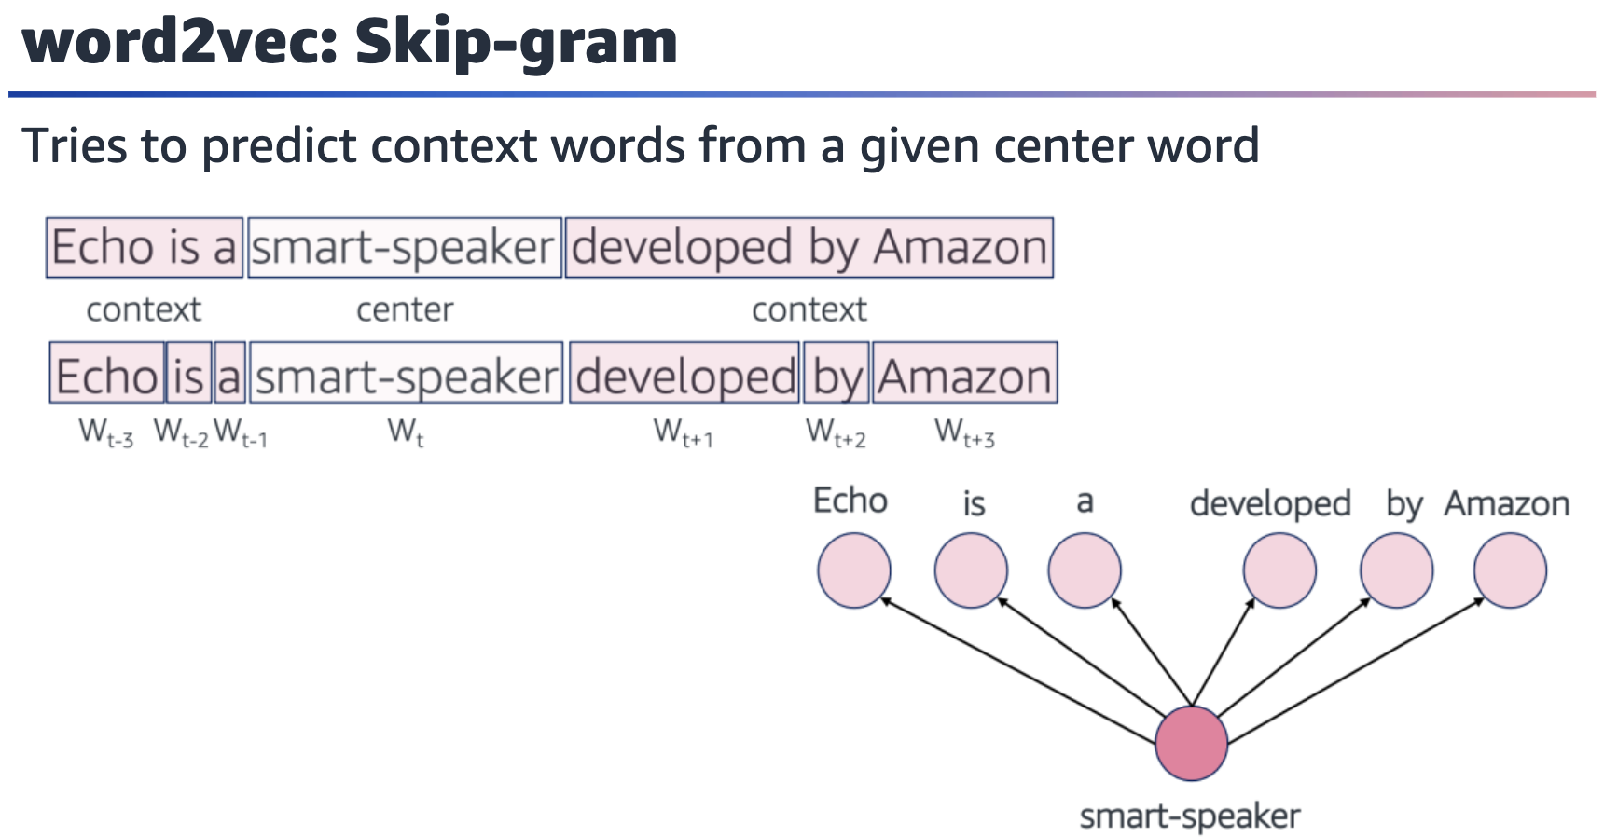

***Image description***: Two examples of the sentence “Echo is a smart-speaker developed by Amazon.” In the first example, “smart-speaker” is identified as the center word, and the phrases “Echo is a” and “developed by Amazon” are context words. In the second example, the context words in the sentence are represented as Wt-3, Wt-2, Wt-2, Wt+1, Wt+2, Wt+3. “smart-speaker” is the center word and is represented as Wt. The center word (*smart-speaker*) is used to predict the context words (*Echo*, *is*, *a*, *developed*, *by*, *Amazon*) ***End description***.

Skip-gram tries to predict context words from a given center word.

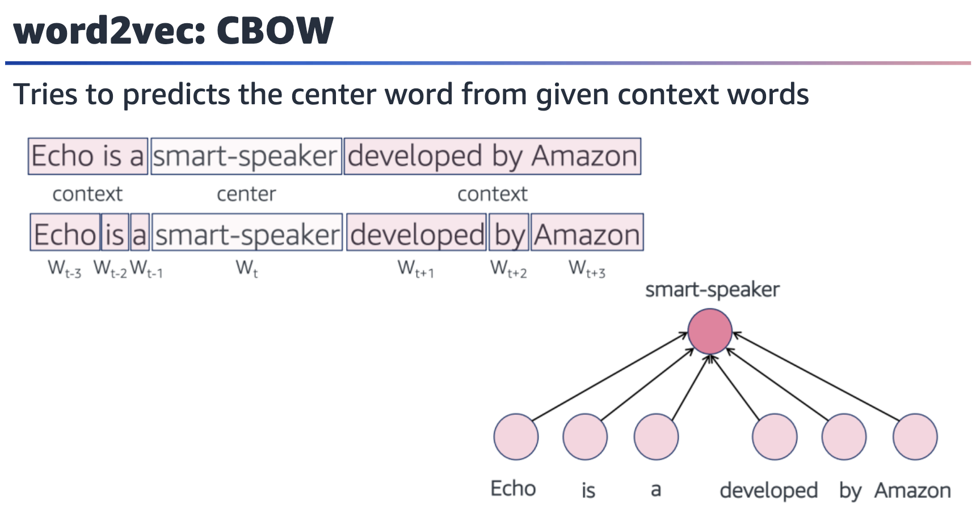

Figure showing that the context words (*Echo*, *is*, *a*, *developed*, *by*, *Amazon*) are used to predict the center word (*smart-speaker*)

The continuous bag-of-words method (CBOW) predicts the center word from given

context words. The algorithm takes a set of context words as input and predicts the

target word. The context words are represented as one-hot vectors, and the algorithm uses a neural network to learn a distributed representation (embedding) of each word. The goal is to minimize the difference between the predicted target word and the actual target word by using techniques such as negative sampling or hierarchical softmax.

In contrast, in Skip-gram, the algorithm takes a target word as input and predicts the

context words around it. The target word is represented as a one-hot vector, and the

context words are sampled from a window around the target word. The algorithm then uses a neural network to learn a distributed representation (embedding) of each word. The goal is to maximize the likelihood of the observed context words by using techniques such as negative sampling or hierarchical softmax.

The key difference between CBOW and Skip-gram is the direction of the prediction.

CBOW predicts the target word from the context, while Skip-gram predicts the

context words from the target word. Additionally, CBOW tends to be faster to train

and performs well on frequent words, while Skip-gram is better suited for infrequent

words and performs well on syntactic and semantic relationships.

For more information, see Word Embedding (word2vec) in Dive into Deep Learning

at <https://d2l.ai/chapter_natural-language-processing-pretraining/word2vec.html>.

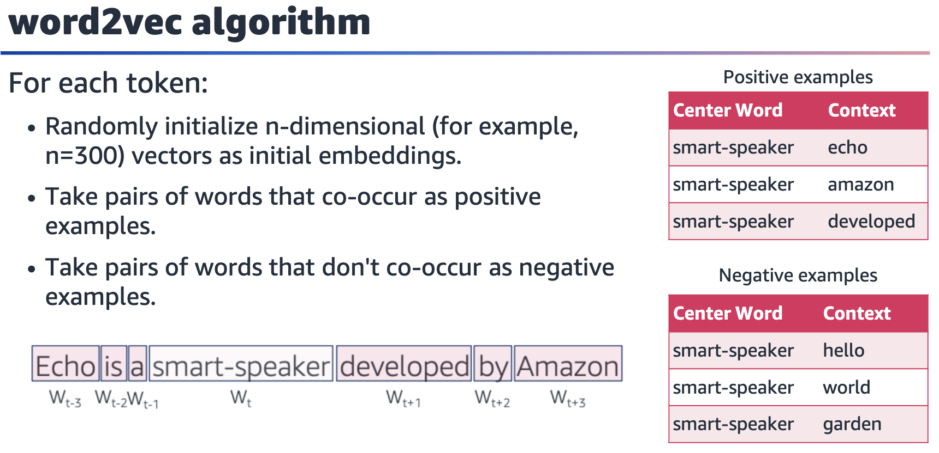

The word2Vec algorithm uses a neural network with a single hidden layer. The input

layer contains one-hot vectors that represent the context words, while the output

layer contains one-hot vectors that represent the target word or context words. The

hidden layer contains the word embeddings, which are learned through backpropagation.

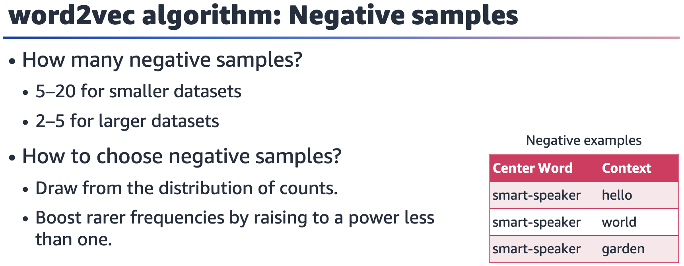

The number of negative samples to use in the word2vec algorithm can depend on the

size of the dataset. Typically, for smaller datasets, the recommendation is to use a

large number of negative samples, such as 5–20, while a small number of negative

samples, such as 2–5, might be sufficient for larger datasets.

Choosing the negative samples is an important part of the word2vec algorithm. One

common method is to draw the negative samples from the distribution of word

counts in the corpus. This means that more frequent words are more likely to be

sampled as negative examples than less frequent words. Another technique is to

boost the frequency of rarer words by raising their counts to a power less than 1. This

can help to give more weight to rare words and improve their representation in the

embedding space.

The choice of the number of negative samples and the method of choosing them can

have a significant impact on the performance of the word2vec algorithm. Therefore,

it’s important to experiment and choose the best approach for a specific dataset and

task.

Reminder: An objective function is a real-valued function whose value is to be either minimized or maximized over the set of feasible alternatives.

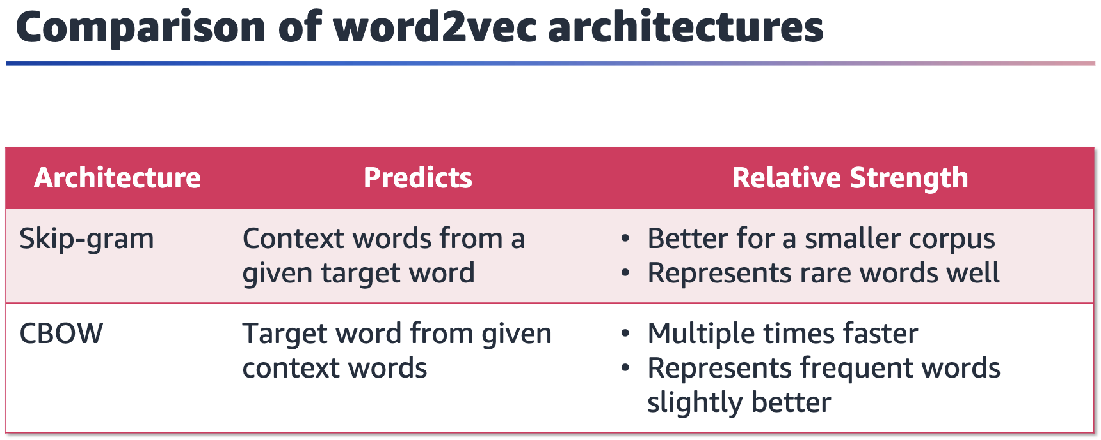

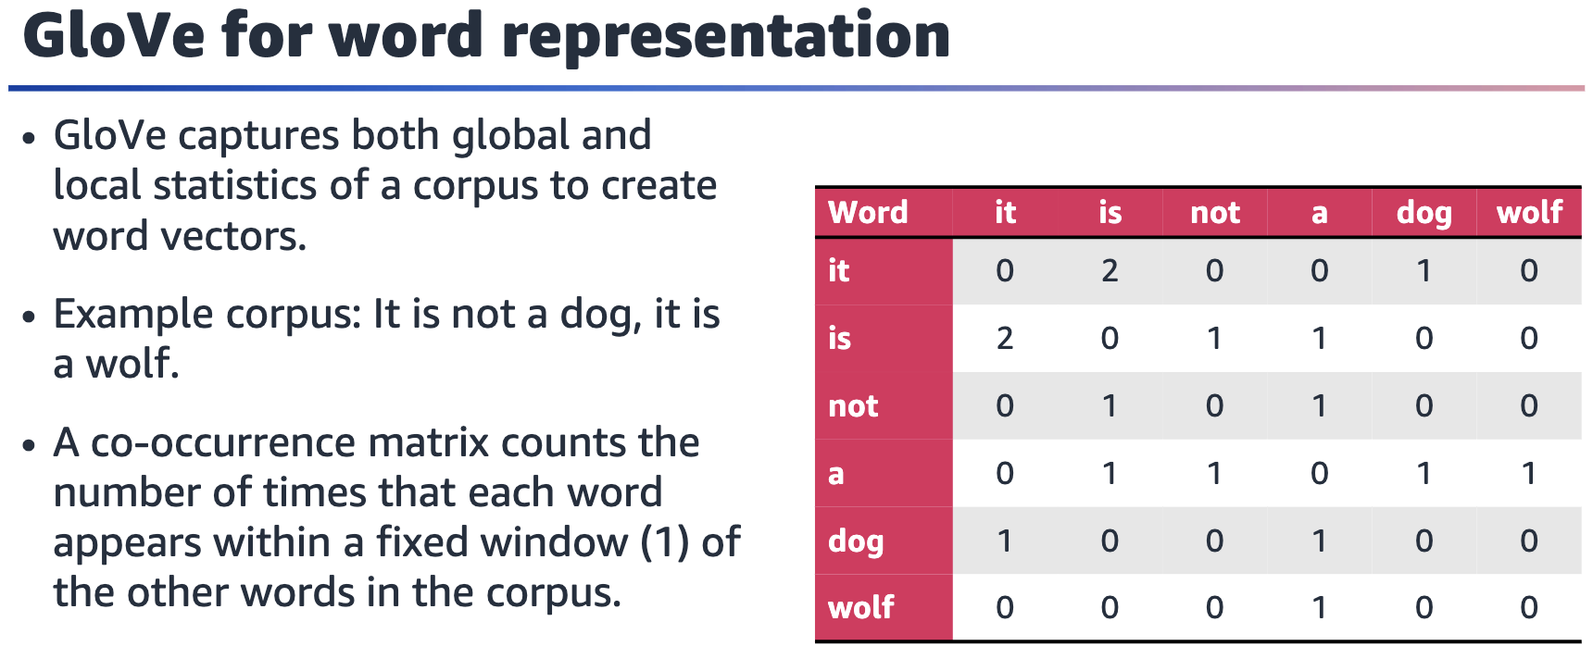

GloVe is a type of word embedding technique that is used to represent words as

vectors of numerical values in a high-dimensional space. The algorithm is based on

the idea that words that appear frequently together in a corpus of text are likely to be

related in meaning.

GloVe uses matrix factorization techniques to learn the relationship between words

by examining the co-occurrence matrix of a corpus of text. The co-occurrence matrix

represents the frequency of each word that appears in the same context as every

other word in the corpus.

In the table on the slide, each row represents a word in the corpus, and each column

represents the count of adjacent occurrences of the other words in the corpus within

a fixed window of 1. For example, the value in the is row and not column is 1, which

indicates that these words appear next to each other once in the corpus. The table is symmetric, so the value in the not row and is column is also 1.

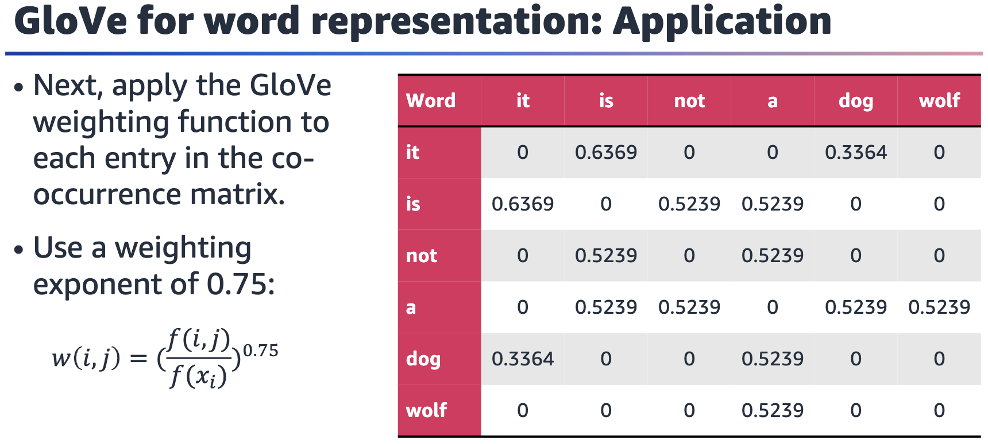

Next, apply the GloVe weighting function to each entry in the co-occurrence matrix. The co-occurrence matrix X will be a V x V matrix, where the ith row and jth column of X, Xij

denotes how many times word I has co-occurred with word j.

For example, use a weighting exponent of 0.75: w(i,j) = (f(i,j) / f(xi)) ^ 0.75

The weighting function gives more weight to the co-occurrences that are less frequent (those that occur in fewer contexts) than to those that are more frequent. This helps to prevent common words, such as *the* and *and*, from dominating the resulting word embeddings. The exponent of 0.75 is a commonly used value in practice, but it can be tuned for specific tasks and corpora.

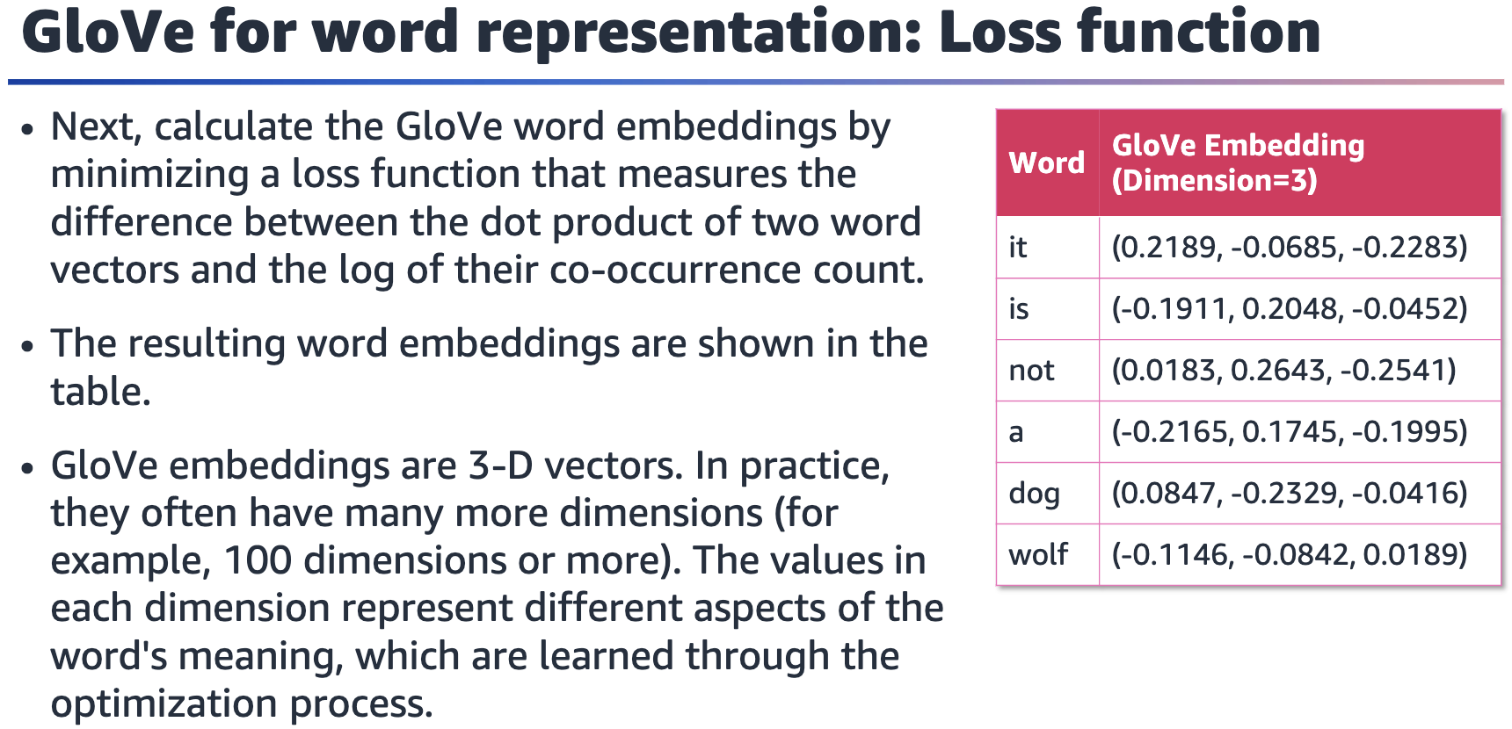

To generate word embeddings from the weighted co-occurrence matrix, you first need to choose a dimensionality for the embeddings. Assume that you want 3-dimensional embeddings. You can use singular value decomposition (SVD) to factorize the weighted co-occurrence matrix into three matrices: a left singular matrix U, a diagonal matrix Σ, and a right singular matrix V^T. Then, use the left singular matrix U to represent each word as a vector of length 3 in the table.

The table on the slide shows the word embeddings for *it*, *is*, *not*, *a*, *dog*, and *wolf* based on the co-occurrence matrix and GloVe weighting function. Note that these embeddings aren’t necessarily directly comparable to embeddings that are generated by using other methods or different parameters.

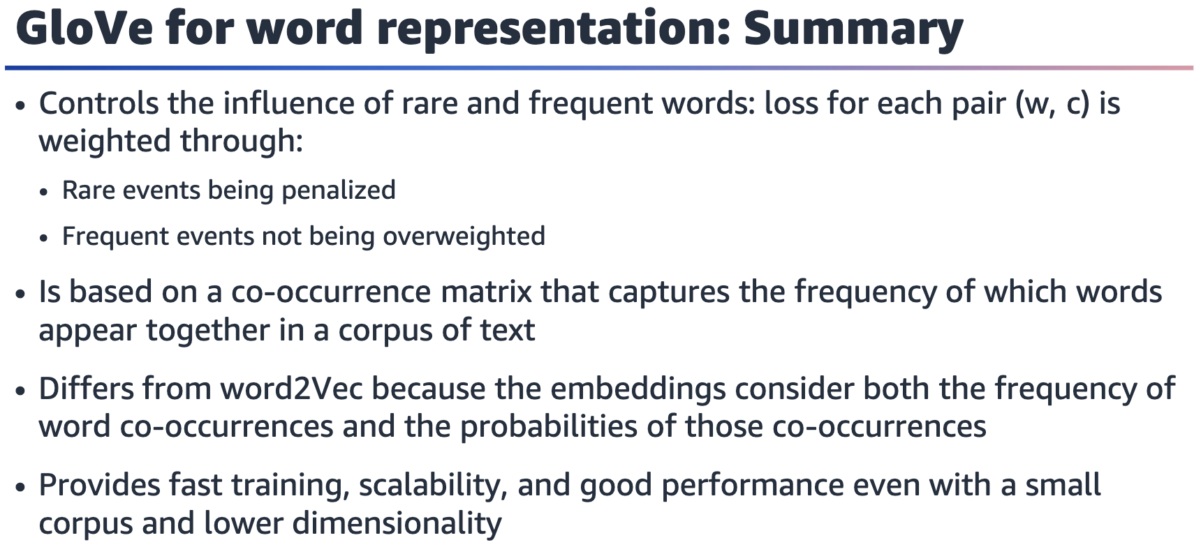

GloVe uses a weighting function to control the influence of rare and frequent words in the co-occurrence matrix. The weighting function assigns a weight to each pair (w,

c) based on the frequency of their co-occurrence. The function is designed to penalize rare events and prevent frequent events from being overweighted.

GloVe embeddings are based on a co-occurrence matrix that captures the frequency

with which words appear together in a corpus of text. The co-occurrence matrix is

factorized using SVD to generate a low-dimensional representation of the words in

the corpus.

GloVe embeddings are different from other word embeddings, such as word2Vec,

because they consider both the frequency of word co-occurrences and the probabilities of those co-occurrences. GloVe embeddings have been shown to perform well on a variety of NLP tasks, including sentiment analysis, language modeling, and named entity recognition.

GloVe embeddings can be pretrained on large corpora of text, such as Wikipedia or

Common Crawl, and then fine-tuned on specific tasks by using smaller datasets. GloVe embeddings are widely used in industry and academia, and are available in popular ML libraries, such as TensorFlow and PyTorch.

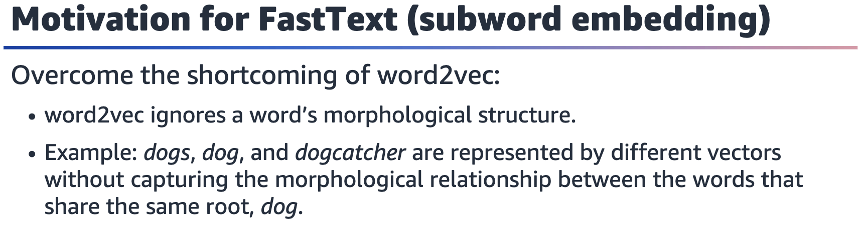

In the context of NLP, the term morphological typically refers to the structure of words and how they can be modified through the addition or removal of affixes. For example, in English, the word jumping is formed by adding the suffix -ing to the verb jump. The word unhappy is formed by adding the prefix un- to the adjective happy.

One shortcoming of word2vec is that it treats each word as a discrete unit and

doesn’t explicitly model the morphological structure of words. This can make it

difficult for word2vec to capture the full range of meaning that is associated with a

word. This occurs particularly in languages with complex morphology where words

can take on many forms depending on their role in a sentence or the affixes that are

attached to them.

For more information about FastText, see the FastText site at <https://fasttext.cc>.

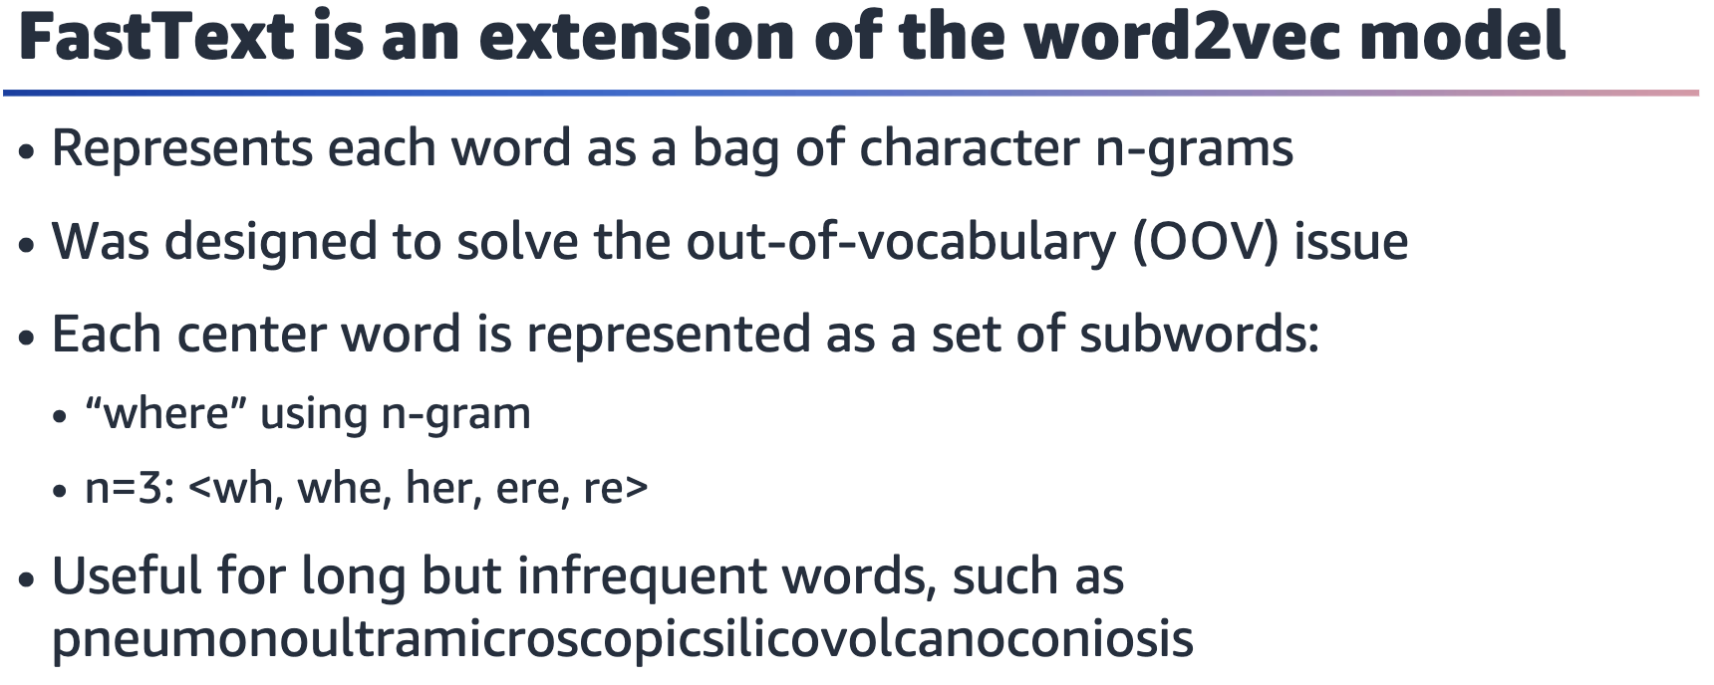

Out-of-vocabulary (OOV) terms aren’t part of the normal lexicon that is found in an

NLP environment. When a word that isn’t in the training set occurs in real data, this

causes a problem.

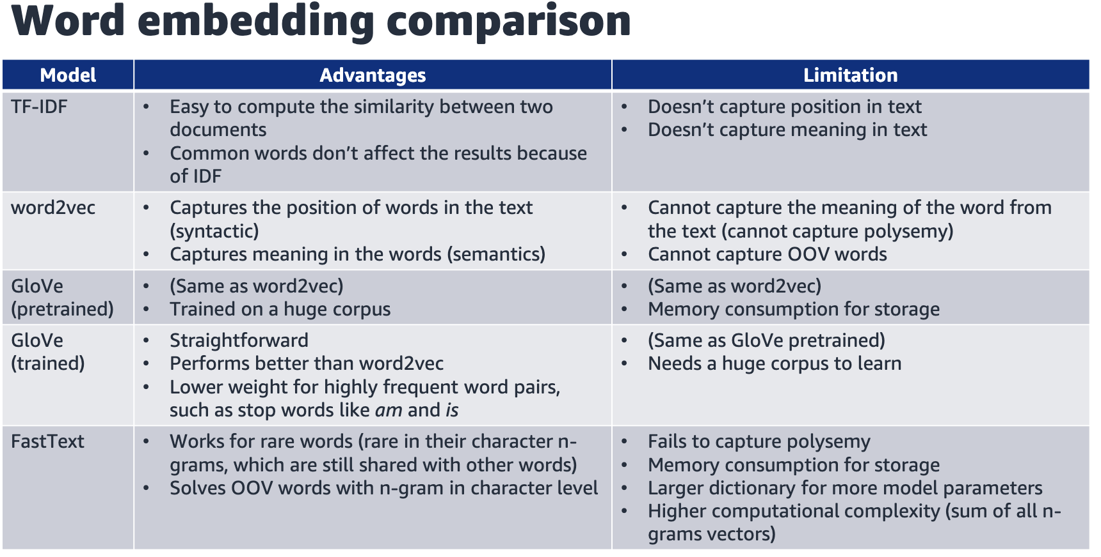

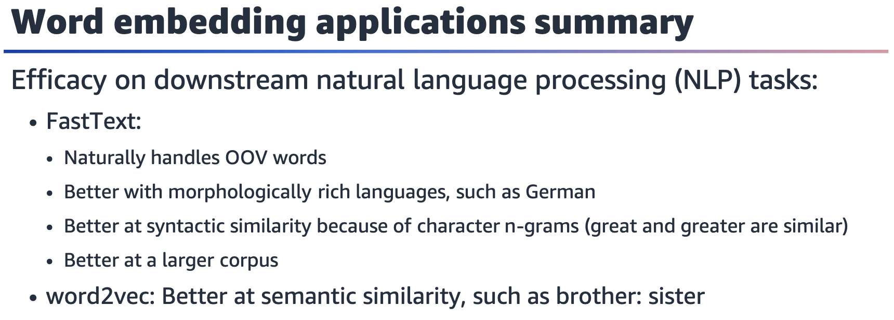

In the context of NLP, downstream typically refers to tasks that use pretrained models or features, such as word embeddings. Downstream is used to distinguish between the initial pretraining phase, in which the word embeddings are learned, and the subsequent phase. In the subsequent phase, the word embeddings are used as input features for downstream NLP tasks, such as text classification, named entity recognition, and sentiment analysis.

The efficacy of different word embedding methods can depend on the specific downstream NLP task and the specific dataset that is being used.

FastText's use of character n-grams helps it to better handle OOV words and capture

morphological information. This feature makes it well suited for tasks such as named

entity recognition and text classification in languages with complex morphology.

FastText’s performance tends to improve with larger training corpora.

word2Vec tends to excel at capturing semantic relationships between words. This

makes it well suited for tasks such as word analogy and semantic similarity.

Of course, the relative performance of these methods can depend on a wide range of

factors, including the specific dataset, choice of hyperparameters, and evaluation

metrics that are used. In practice, it's often a good idea to try multiple embedding

methods and compare their performance on the specific task and dataset.

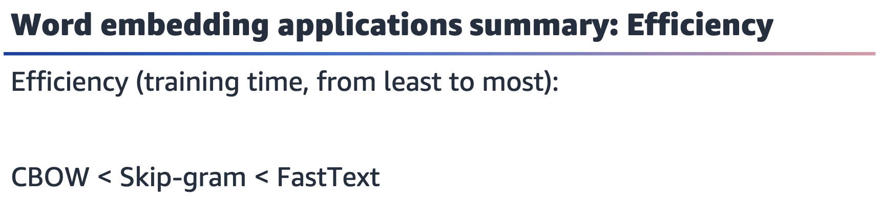

In general, FastText is slower than both CBOW and Skip-gram because FastText involves training on character n-grams in addition to word embeddings.

Between CBOW and Skip-gram, CBOW is generally faster because it involves predicting the target word from the context words. Skip-gram involves predicting the

context words from the target word. The larger the context window size, the slower

that CBOW and Skip-gram become.

However, the actual training time can vary depending on several factors, such as the

size of the training corpus, size of the embedding vectors, number of training epochs,

and hardware that is used for training. Therefore, it's difficult to give a definitive

answer about the relative efficiency of these methods without specific details about

the training setup.

